Guest Network Access
Official URL: https://services.smsu.edu/TDClient/180/Portal/KB/Article/2496/Guest-Network-Access
Category: Knowledge Base > Information Technology Services > Wifi and Network > Guest Network Access
Tags: access, wifi, guest
_____________________________________________________

SMSU Guest Wi‑Fi Access
Welcome to Southwest Minnesota State University (SMSU). Visitors can connect to the campus network using the SMSU‑Guests Wi‑Fi network.
To connect, you will need:
- A device with Wi‑Fi enabled
- A valid personal email address or
- A sponsor with an SMSU email address (student or employee)
Who Should Use This Network
- Visitors and guests should follow the instructions in this article.
- Students should use the Student Network Access article.
- Faculty and staff should use the Faculty & Staff Network Access article.
Using the correct network helps ensure secure and reliable access.

How to Connect to SMSU‑Guests Wi‑Fi
- Open the Wi‑Fi settings on your device.
- Select SMSU‑Guests from the list of available networks.
- A sign‑in page will open automatically in your web browser.
If the page does not open, open a browser and visit any website to trigger it.
- If the page does not open, open a browser and visit any website to trigger it.
You will see two sign‑in options:
- Sign In with Email
- Sign In as Guest (Sponsor Approval Required)
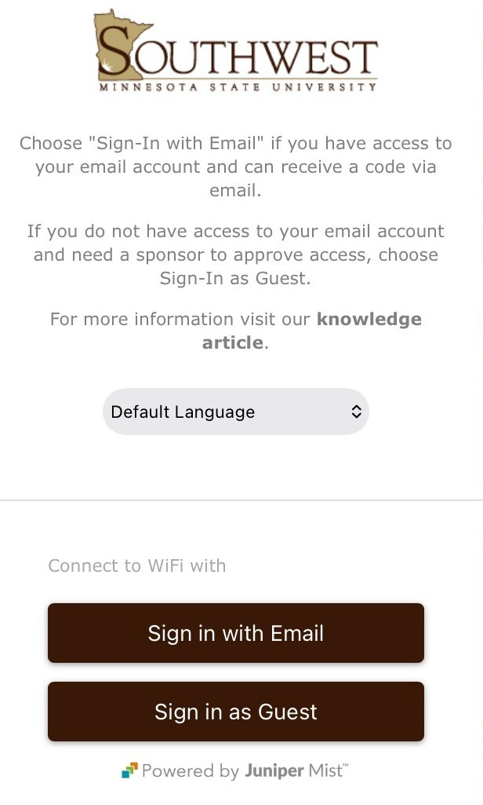
Figure 1: Southwest Minnesota State University Wi-Fi guest access login page. The page includes instructions stating to choose “Sign-In with Email” if the user can access their email to receive a code, or “Sign-In as Guest” if email access is unavailable and a sponsor is required. A “Default Language” dropdown is shown. At the bottom, two buttons read “Sign in with Email” and “Sign in as Guest,” with “Powered by Juniper Mist” displayed beneath.

Option 1: Sign In with Email
Choose this option if you can access your personal email and receive a verification code.
Steps
- Enter your name and personal email address.
- Select Send Access Code.
- Check your email for a message from no‑reply@mist.com.
- Return to the sign‑in page and select I have an access code.
- Enter the access code from the email to complete the connection.
You will be connected to the SMSU‑Guests Wi‑Fi once the code is verified.
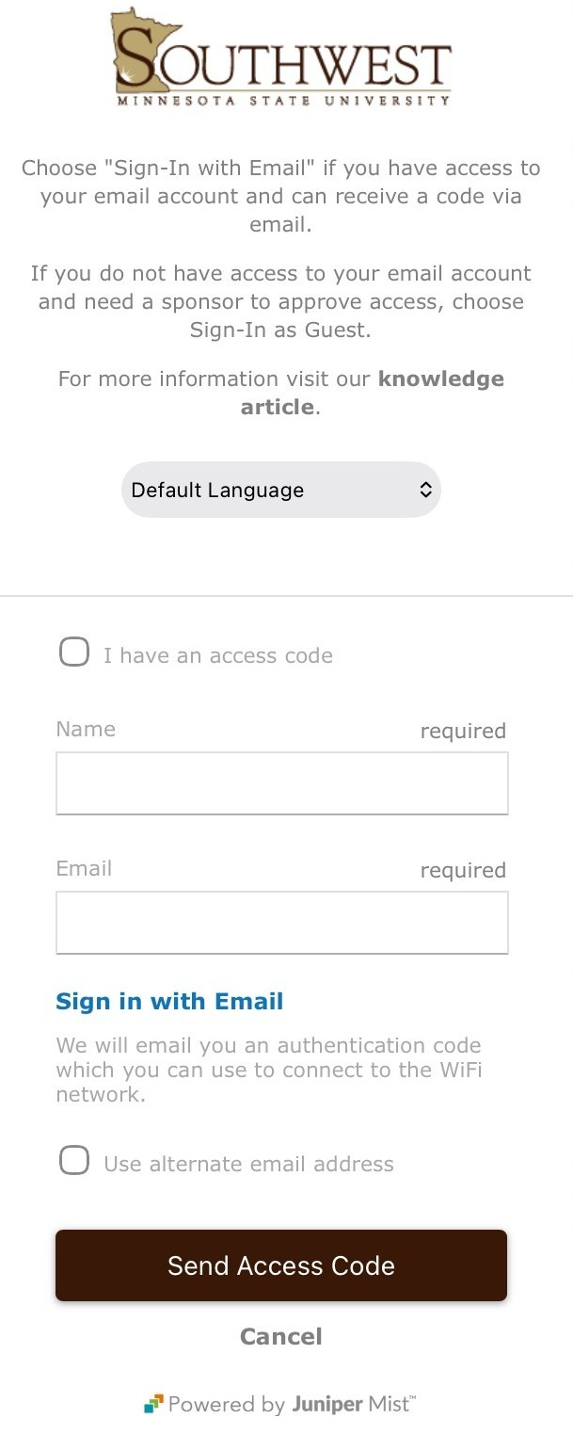
Figure 2: Southwest Minnesota State University guest Wi‑Fi sign-in page showing instructions to use email authentication. The page includes a checkbox labeled “I have an access code,” required input fields for name and email, and a note that an authentication code will be emailed. There is an option to “Use alternate email address,” a “Send Access Code” button, a “Cancel” link, and “Powered by Juniper Mist” displayed at the bottom.

Option 2: Sign In as a Guest (Sponsor Required)
Choose this option if you do not have access to your email account.
A sponsor must be:
- A current SMSU student, faculty member, or staff member
- Someone with an active @smsu.edu email address
Steps
- Enter your name and personal email address.
- Enter your sponsor’s name.
- Enter your sponsor’s SMSU email address.
- Select Request Wi‑Fi Access.
- Your sponsor will receive an approval email from no‑reply@mist.com.
- Once your sponsor approves the request, your device will connect automatically to SMSU‑Guests.
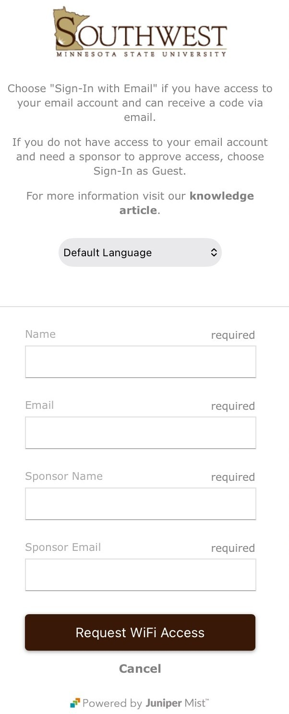
Figure 3: Southwest Minnesota State University guest Wi‑Fi sponsorship request page. The screen displays instructions about signing in with email or as a guest and includes a “Default Language” dropdown. Below are required fields for Name, Email, Sponsor Name, and Sponsor Email. A “Request WiFi Access” button and a “Cancel” link appear at the bottom, along with “Powered by Juniper Mist.”

Need Help?
If you experience issues connecting:
- Confirm that the email address was entered correctly.
- Check spam or junk folders for messages from no‑reply@mist.com.
- Contact your sponsor to ensure they approved the request.
For additional assistance, contact the Technology Resource Center (TRC).

Requesting Event Wi‑Fi Access
To request an event Wi‑Fi passphrase, submit an Event Credential Request.
What to Expect
- The request allows SMSU Information Technology Services to create a temporary passphrase for your event.
- The passphrase can be shared with event attendees to connect to SMSU‑MyWifi.
- Event access is time‑limited and intended only for the duration of the event.
Accessibility Review & Update Log:
- [ ] Content accuracy verified
- [ ] Color contrast checked
- [x] Image alt-text verified (screenshots auto-captioned)
- [x] Document structure and headings formatted (perfect bold, list bulletpoints and sequences preserved)

